**Tableau Project on E-Fixed Deposits**

Q1) Create a dashboard for senior management to view FDs created over the last 6 months. Make assumptions as appropriate and create the dashboard using your own mock data. For any missing data, make your assumptions to create mock data. Write down the assumptions as well.

Ans) The dashboard for senior management of FD creation over last 6 months is mentioned below:

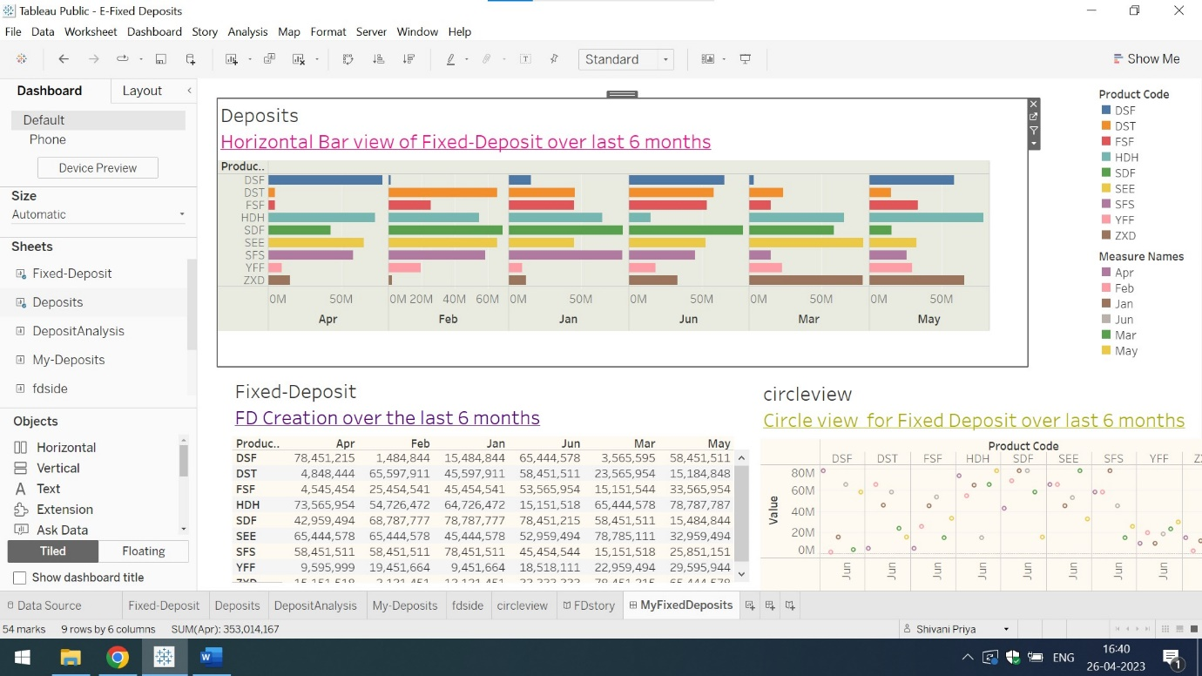

For more detailed explanation of story and dashboard click on the below mentioned link:

<https://public.tableau.com/app/profile/shivani.priya8178/viz/E-FixedDeposits_16825030267760/MyFixedDeposits?publish=yes>